**Reduce, Reuse, Recycle – Yes, the Order Matters.**

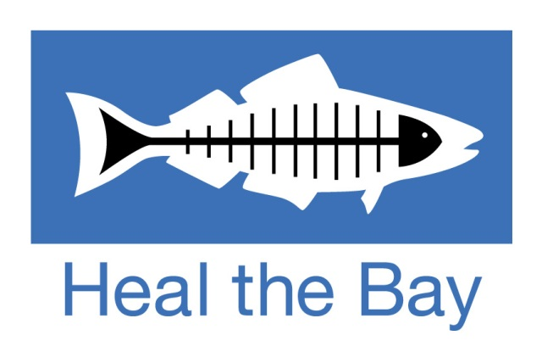

**Vocabulary**

|  |  |  |
| --- | --- | --- |
| **English** | **Example phrase/Memory aid** | **German** |
| crucial | essential, vital, decisive | ausschlaggebend, entscheidend |
| billion | German “Billion” = English  “trillion” | Milliarde |
| to transition | to change from one state or condition to another; transition *(n.)* | in etw. übergehen |
| single-use plastic | single use <-> reusable | Einwegplastik |
| infinite(ly) | endless(ly), indefinite(ly) | unendlich |
| to downcycle | downcycle <-> upcycle |  |
| to repurpose | to give sth. another purpose; to reuse, to recycle | umfunktionieren |
| FSC-certified paper | paper certified by the **F**orest **S**tewardship **C**ouncil; paper from responsibly managed forests | FSC-zertifiziertes Papier |
| locally-sourced materials |  | lokal bezogene Materialien |
| to dispose of | to throw away; (waste) disposal *(n.)* |  |
| plastic tub | small container made of plastic | Plastikbecher, -dose |
| sewing kit | small package with needles and thread for sewing sth. | Nähset |
| to triple | to become three times as much or many; also: to double, to quadruple | verdreifachen |
| to disrupt | to drastically change, to interrupt; disruption *(n.)*; disruptive (adj.) | unterbrechen, stören, durcheinanderbringen |
| to conduct | to carry out | durchführen |
| waste audit | process of checking the amount and types of waste you generate; audit = (official) inspection | Abfallprüfung |
| quarantine | isolation in order to prevent the spread of infectious diseases; to quarantine *(v.)* | Quarantäne |
| public relations | professional maintenance of a favourable public image (of a company or public figure) | Öffentlichkeitsarbeit |
| internship | mainly AE; BE = work experience, work placement | Praktikum |
| to encompass | to include, to comprise | umfassen, beinhalten |